Implementation of Wireless Sensor System for Soil NPK analysis using Lagrange’s interpolation method.

## *Abstract*—India is an agriculture-based country, the Indian economy is predominantly dependent on the agriculture sector. The agricultural yield primarily depends on the fertility of the soil and the appropriate use of the fertilizers. The current method to measure soil nutrients yields lesser accuracy due to difference in time when soil sample was collected and measured in the laboratory. To address this challenge and increase the profit percentage, we need to adopt new technologies for precise agricultural practices. We propose the system with Wireless Sensor Network for monitoring the NPK values using sensor nodes. This system will deliver the end-user with proper recommendations about the required fertilizer ratio based on soil nutrients of the land.

**Index Terms: Wireless Sensor Network, Precision Agriculture, Soil Nutrient, Lagrange’s interpolation Method.**

I. INTRODUCTION

India is a highly populated country with over 50% population dependent on agriculture. Due to aberration in climate, the farmers are in distress. The fertility of the soil and the appropriate use of fertilizers is crucial for better crop yield. Predicting the quantity of fertilizers to be used can help the farmers in precision agriculture. Nitrogen (N), Phosphorus (P), and Potassium (K) are the major nutrients contained in the soil to provide fertility and crop yield. Measuring the nutrient content present in the soil is necessary for predicting the required additional quantity of nutrients to increase crop yield and maintain the fertility of the soil. Many farmers are not exposed to modern technology and still use traditional ways to increase crop yield. An agricultural monitoring system will help in delivering and controlling services for a field and will lead to crop growth in an optimal status. A Wireless sensor network is deploying sensor nodes on the field for gathering data at one master base station for analysis.

1. ***Wireless Sensor Network***

Wireless Sensor Network is an emerging technology that helps the development of precision agriculture. WSN comprises of sensors and micro-controllers to process the data, battery or source of powers, base station to transmit the data. Recent trends and advancements in WSN technology have carved the path for the development of less cost. Low consumption of power and multi-functioning sensor nodes. Sensor node deployed at different places senses the different environmental parameters at that place and the processes the data accordingly. Sensor nodes can monitor parameters like soil fertility, temperature, humidity, moisture, etc. WSN has a wide range of applications in fields of agriculture, military, industries. In the agricultural field, WSN can

be used for real-time monitoring of data on the field. In our case, it is to monitor the NPK fertilizer values.

1. ***NPK Fertilizers***

The plant uses three macro-nutrients nitrogen(N), phosphorus(P), potassium(K) that is NPK, nitrogen n is responsible for the growth of leaves on the plant. Phosphorus is responsible for root growth and flower and fruit development. Potassium is a nutrient that helps the overall functions of the plant perform correctly. Knowing the NPK value of the soil will help in calculating the optimal value of the fertilizer required.

.

1. ***Architectural design.***

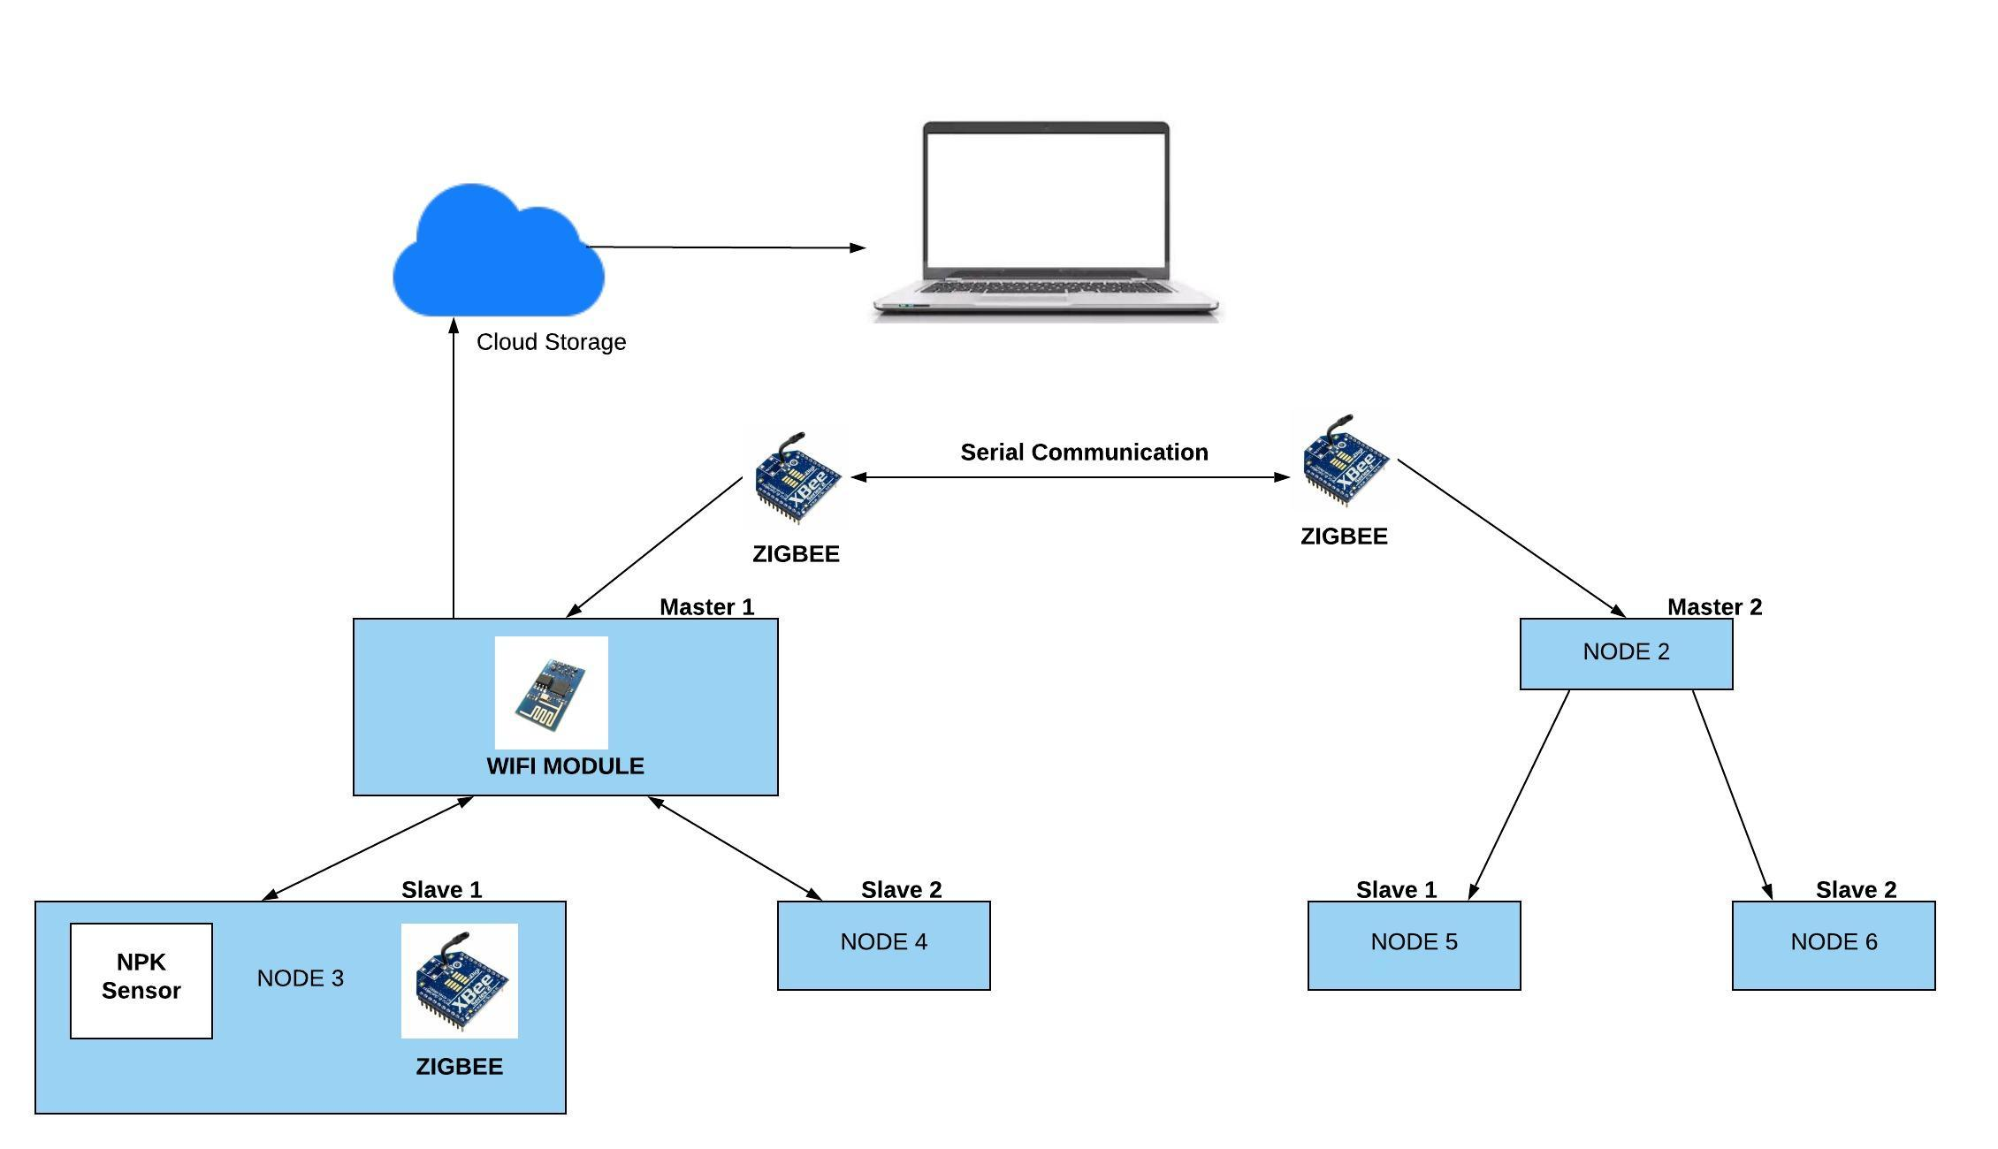

*Fig. 1. Architectural Design*

# LITERATURE REVIEW

Madhura U K *et. al.*, [1] Soil Quality Management using Wireless Sensor Network. In this paper, the Wireless Sensor Networks are used to examine environmental conditions using a set of spatially distributed sensors. Incorporating Wireless Sensor Network into the proposed Soil Quality Management System makes it possible to measure various qualities of soil like Electrical Conductivity, pH, temperature, NPK (Nitrogen Phosphate Potassium) content, and light intensity.

Nasrin Akter Ripa *et. al.*, [2] Analysis of Newton’s Forward Interpolation Formula. In this paper they presents a theoretical analysis Newton’s Forward Interpolation Formula. In order to analyze the method, unit step, unit ramp and sinusoidal signals are used. Also, to check the performance of the considered method an increasing function and a decreasing function has considered. Some sampled values of a signal are calculated and then the Newton’s forward Interpolation formula is used to reconstruct the signal such as image resizing.

Asmita Singh, *et. al.*, [3] Energy Efficient WSN for Precision Agriculture – Using Modified Zonal Stable Election Protocol. In this paper, they can observe soil parameters like temperature, water content, moisture using Modified Zonal Stable Election Protocol (MZSEP) which follows hybrid routing for heterogeneous networks. WSN collects data through real-time monitoring and then transmits it to the Base Station. Data received is then displayed at the base station to achieve the monitoring of various soil parameters for efficient use of resources

Marianah Masrie, *et. al.*, [4] Integrated optical sensor for NPK Nutrient of Soil detection. In this paper, they have briefly explained the working of optical sensors uses for NPK analysis. The optical sensor is developed with two systems which are transmission system and detection system. The transmission system uses LED powered by Arduino UNO as a component to transmit light directly on the soil which contains nutrients in a transparent container. The detection system utilized two photodiodes developed with a signal conditioner and an amplification circuit to detect the intensity of nutrients of the soil through the remaining light and to amplify the signal of light in terms of potential differences. The results show that the values of N, P and K.

Rajinder Kumar, *et. al.*, [5]A wireless sensor network based low cost and energy-efficient framework for precision agriculture. In this paper, the authors have proposed a framework for precision agriculture. They have used low cost, high accuracy, and high range sensor for real-time monitoring of the crop field. They deployed temperature sensors, moisture sensors, and humidity sensors and connected with Zigbee for wireless communication.

Sonal Verma *et. al.*, [7] Wireless Sensor Network for Crop Field Monitoring. This paper presents the design and the implementation of a Wireless Sensor Network that can monitor the air temperature, humidity and ambient light intensity in a crop field. The system consists of nodes, which are equipped with small size application specific sensors and radio frequency modules. The sensor data is transmitted via radio frequency link to the centrally localized computer terminal for data logging and analysis.

Dhanapriya.M *et. al.*, [8] Estimation of micro and macro nutrients in the soil of remote areas. This paper focuses on analyzing the content of micro nutrients and macro nutrients present in the soil. . In the present system, the kit is placed deep in the soil with GPS and GPRS and the results are being analyzed. This simulation part is designed using PROTEUS software. A soil fertility test evaluates the nutrient-supplying power of a soil. The results of the test are used to predict if, or how much fertilizer is required for optimum plant growth. Soil fertility categories include Deficient, Optimum, and Exceeds crop needs using Atmel 89c51 microcontroller

Akshay Tekam *et. al.,* [9] Implementation of Wireless Sensor System for Soil NPK analysis using Runge-Kutta Method. In this paper the authors explained about existing methods for precision agriculture using WSN. The author has proposed a system with Wireless Sensor Network for NPK monitoring using sensor nodes. The system uses Range-Kutta Method to analyse the NPK values and recommend the required proportions of fertilizers.

Santosh Warpe *et. al.,* [10] A Study of fertilizer distribution system for Agriculture using Wireless Sensor Network. In this paper the author presents the study of Wireless Sensor Network that are applied in agriculture for automated farming. In this paper the survey on Wireless Sensor Network was carried out to determine the need for an Automated System for distribution of fertilizers.

# CONCLUSION

The Wireless Sensor Network (WSN) implemented for analysis of soil nutrients provides an efficient way to measure soil nutrients and monitor field data from remote location.

The proposed system takes into account the existing nutrient content of soil, performs analysis on the data collected and gives recommendation with respect to the need of the crop using Lagrange’s interpolation method.

ACKNOWLEDGEMENT

The authors would like to express special thanks of gratitude to

* Prof. Santosh T. Warpe Department of Computer Engineering MIT Academy of Engineering Alandi, Pune.
* Prof. Manish Giri Department of Computer Engineer- ing MIT Academy of Engineering Alandi, pune.

1. Madhura U K, Akshay P, Akshay J Bhattad, Nagaraja G S: 2nd IEEE International Conference on Computational Systems and Information Technology for Sustainable Solutions 2017.
2. Analysis of Newton’s Forward Interpolation Formula.Nasrin Akter Ripa. 4. International Journal of Computer Science & Emerging Technologies (E-ISSN: 2044-6004)Volume 1, Issue 4, December 2010.
3. Energy Efficient WSN for Precision Agriculture – Using Modified Zonal Stable Election Protocol . 2019 6th International Conference on Signal Processing and Integrated Networks (SPIN)
4. Integrated optical sensor for NPK Nutrient of Soil detection. Proc. of the 2018 IEEE 5th International Conference on Smart Instrumentation, Measurement and Applications (ICSIMA 2018) 28-30 November 2018, Songkhla, Thailand.
5. A wireless sensor network based low cost and energy efficient frame work for precision agriculture Rajinder Kumar Math; Nagaraj V Dhar- wadkar 2017 International Conference on Nascent Technologies in En- gineering (ICNTE) Year: 2017
6. Wireless Sensor Network for Crop Field Monitoring, Sonal Verma, Nikhil Chug, Dhananjay V. Gadre. 2010 International Conference on Recent Trends in Information, Telecommunication and Computing New Delhi.
7. Estimation of micro and macro nutrients in the soil of remote areas.Dhanapriya.M*, Maheswari.R. International Conference on Science, Technology, Engineering & Management[ICON-STEM’15]
8. Akshay Tekam, Vinod Rawool, Shridhar Rakshe, "IMPLEMENTATION OF WIRELESS SENSOR SYSTEM FOR SOIL NPK ANALYSIS USING RUNGE-KUTTA METHOD", IJRAR - International Journal of Research and Analytical Reviews (IJRAR), E-ISSN 2348-1269, P- ISSN 2349-5138, Volume.6, Issue 1, Page No pp.521-523, March 2019
9. Santosh T Warpe and Ravi Singh Pippal. A Study of Fertilizer Distribution System for Agriculture using Wireless Sensor Network. International Journal of Computer Applications 147(2):43-46, August 2016